

SESSION 2022-23

HTML

(Hyper-Text-Markup Language)

Lab File

**COURSE:- BCA**

**ROLL NO :- 41221139**

**SUBMITTED BY :- SUBMITTED TO:-**

**Sachin Rajbhar Mrs. Shilpa Ma’am**

|  |  |  |  |
| --- | --- | --- | --- |
| I N D E X | | | |
| S.NO | **P R A C T I C A L S** | **DATE** | **SIGN.** |
| 1 | **Creating First HTML web page.** | 26/09/22 |  |
| 2 | **Basic formatting tags in HTML.**   1. Paragraph Tag 2. Bold Tag 3. Italic Tag 4. Underline Tag 5. Line break 6. Horizontal line 7. Subscript 8. Superscript 9. Emphasized 10. Strong 11. Big 12. Small | 3/10/22 |  |
| 3 | **Heading tags in HTML.**  <H1>….</H1>……………………..<H6>…</H6> | 3/10/22 |  |
| 4 | **More formatting tags in HTML.**   1. <FONT> </FONT>  * Text color * Face * Size * Align -> [Left,Right,Center]  1. Background color 2. Pre-formatting tags | 3/10/22 |  |
| 5 | 2AGI + Na2S --> Ag 2+2NaI 8CO + 17H 2---> C 8H 18 + 8H 2O 10KClO 3 + 3P4O 10 + 10KCl SnO 2 + 2H 2---> Sn + 2 2H 2O (a+b) 2---> a 2 + b 2 + 2ab 5x 2 + 7x = 3x 2 + 2x 2 + 4x + 8 (a+b) 3 = a 3 + b 3 + 3ab(a+b) |  |  |
| 6 | List in HTML.   1. Ordered list 2. Unordered list 3. Definition list |  |  |
| 7 | 1. Input Devices 2. Keyboard 3. Mouse 4. Joystick 5. Scanner 6. Flatbed scanner 7. Hand held scanner 8. Output Devices 9. Monitor 10. LCD 11. CRT 12. Printers 13. Impact printers 14. Non-Impact printers | 17/10/22 |  |
| 8 | |  |  |  |  |  |  | | --- | --- | --- | --- | --- | --- | | IP UNIVERSITY COURSES | | | | | | | Graduate | | | Undergraduate | | | | BBA | BCA | B.Tech | MBA | MCA | M.Tech | | 240 | 120 | 120 | 200 | 100 | 80 | |  |  |
| 9 | Apply Marquee tag on image and text with all four directions and three behaviours. |  |  |
| 10 | Create a user registration form. |  |  |
| 11 | Create a user form. |  |  |
| 12 | Design of web page to display the syllabus of BCA clicking on each subject should open its description in new document (WTE,PYTHON,DBMS). |  |  |
| 13 | Create a web page to show input and output devices with image. Clicking on the input and output devices image would open its description in a new document. |  |  |
| 14 | Create a static web page which defines all text formatting tax in HTML in tabular form   |  |  | | --- | --- | | Formatting tags | usage | | Bold |  | | Italic |  | | Underline |  | | Emphasized |  | |  |  |
| 15 | Design a HTML webpage (Two frame division) of your favourite movie. Give an attractive look to it. |  |  |
| 16 | Design a HTML webpage (Three frame division) of list , table & frames . Give an attractive look to it.  Main Menu  List  Table  Frames  Explanation  View Example  Example |  |  |
| 17 | Write a program to find out largest of two numbers in JavaScript. |  |  |
| 18 | Write a program to find the Fibonacci series in JavaScript. |  |  |
| 19 | Write a program in JavaScript to find out the year entered by the user is leap or not |  |  |
| 20 | Write a program to find out the largest of three numbers in PHP. |  |  |
| 21 | Write a program in PHP to show that string entered is palindrome or not. |  |  |
| 22 | Write a program in PHP to print the array of names of five subjects using for loop. |  |  |
| 23 | Write a program in PHP to display a multidimensional array of class record of five students as Roll no., Student name and Total marks using for loop. |  |  |
| 24 | Write a program in PHP to arrange the Price of five products in Ascending and descending order using all sort functions(sort, rsort, ksort, krsort, asort, arsort) in arrays. |  |  |
| 25 | Design the registration form for a web site and when the user clicks on submit button the login form should be appeared on the screen. |  |  |
| 26 | Create a webpage displaying Questionnaire related to any survey of your choice. |  |  |
| 27 | Design a webpage presenting your Academic Details also format the details. |  |  |

**PRACTICAL 1**

**Q**: Creating First HTML web page.

**CODE:**

<html>

<body>

<h1>Hello World</h1>

</body>

</html>

**OUTPUT:**

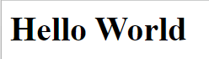

**PRACTICAL 2**

**Q**: Basic formatting tags in HTML.

**CODE:**

<html>

<body>

<u><i><b>Introduction</b></i></u>

<hr>

<p>

I am Sachin Rajbhar.<br>

I am 20 years old.<br>

My hometown is UP.

</p>

</body>

</html>

**OUTPUT:**

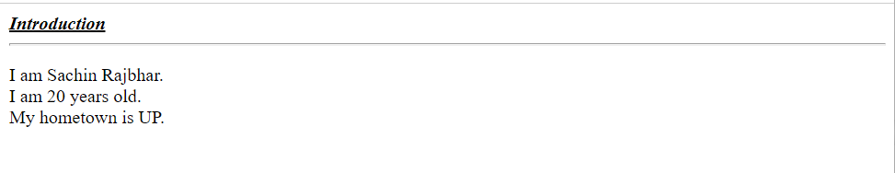

**PRACTICAL 3**

**Q:** <H1>….</H1>……………………..<H6>…</H6>

**CODE:**

<html>

<head>

    <title>Heading Tags</title>

</head>

<body>

    <h1>HEADGING 1</h1>

    <h2>HEADGING 2</h2>

    <h3>HEADGING 3</h3>

    <h4>HEADGING 4</h4>

    <h5>HEADGING 5</h5>

    <h6>HEADGING 6</h6>

</body>

</html>

**OUTPUT:**

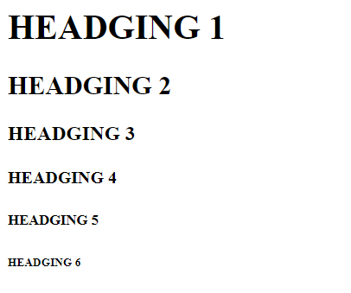

**PRACTICAL 4**

**Q**: More formatting tags in HTML.

**CODE:**

<html>

<head>

    <title>More Format Tags</title>

</head>

<body bgcolor="grey">

    <font size=3 face="ARIAL" color=00AF02 align="left">Font Tag</font>

    <pre>

        a

    a       a

a               a

    </pre>

</body>

</html>

**OUTPUT:**

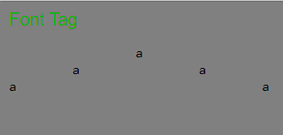

**PRACTICAL 5**

**Q**: Format example (Use of Sub and Sub tags)

**CODE:**

<html>

<head>

    <title>Sup & Sub Tags</title>

</head>

<body>

    <pre>

        2AGI + Na<sub>2</sub>S ->Ag<sub>2</sub>S + 2NaI

        8CO + 17H<sub>2</sub> -> C<sub>8</sub>H<sub>18</sub> + 8H<sub>2</sub>O

        10KClO<sub>3</sub> + 3P<sub>4</sub> -> 3P<sub>4</sub>O<sub>10</sub> + 10KCl

        SnO<sub>2</sub> + 2H<sub>2</sub> -> Sn + 2H<sub>2</sub>O

        (a+b)<sup>2</sup> -> a<sup>2</sup> + b<sup>2</sup> + 2ab

        5x<sup>2</sup> + 7x = 3x<sup>3</sup> + 2x<sup>2</sup> + 4x + 8

        (a+b)<sup>3</sup> = a<sup>3</sup> + b<sup>3</sup> + 3ab(a+b)

    </pre>

</body>

</html>

**OUTPUT:**

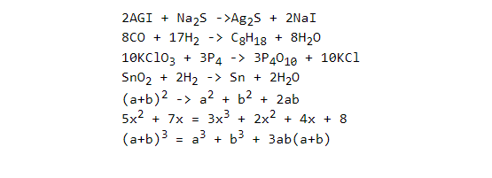

**PRACTICAL 6**

**Q**: List in HTML.

**Unordered List:**An Unordered list is used to create a list of related items, in bulleted or unordered format. It starts with the <ul> tag, followed by the <li> tag to show list items inside <ul> tag.

**Syntax:**

<ul>

<li>Item1</li>

...

</ul>

We can also use different CSS properties to create a list with different styles. It can have one of the following values :

* **circle**: It gives a circle list item marker.
* **square**: It gives square as list item marker.
* **disc**: This is the default filled circular bullet item marker.
* **none**: This is used to unmark list items.

**Ordered Lists:** The Ordered lists have an order which is either numerical or alphabetical. The <ol> tag is used to create ordered lists in HTML and just like unordered list, we use <li> tag to define or show lists inside <ol> tag.

**Syntax:**

<ol>

<li>Item1</li>

<li>Item2</li>

<li>Item3</li>

</ol>

The ordered list has a type operator which defines what type of order the list will have, like whether the list will start with a numerical value or an alphabetical value. The various ways to use the ordered list, are given below:

* **type = “1”**: List will start from 1.
* **type = “A”**: Here the list will start from A.
* **type = “a”**: Here the list will start from lowercase a.
* **type = “I”**: The list will start from Roman numbers.
* **type = “i”**: TheList will start form lowercase Roman numbers.

**Description List:**A description list is a type of list where each item has a description. It is also known as a definition list. The <dl> tag is used to create description list, the <dt> tag defines the item, and the <dd> tag describes each item in list.

**Syntax:**

<dl> Contents... </dl>

The HTML definition list contains following 3 tags:

* [**<dl>**](https://www.geeksforgeeks.org/html-dl-tag/): It defines the start of the list.
* [**<dt>**](https://www.geeksforgeeks.org/html-dt-tag/): It defines a item.
* [**<dd>**](https://www.geeksforgeeks.org/html-dd-tag/)**:** It defines the description of each item.

**PRACTICAL 7**

**Q**: Listing Example

**CODE:**

<html>

    <head>

        <title>List</title>

    </head>

    <body>

        <th>1. Input Devices</th>

        <ol type="i">

            <li>Keyboard</li>

            <li>Mouse</li>

            <li>Joystick</li>

            <li>Scanner</li>

            <ol type="a">

                <li>Flat Bed Scanner</li>

                <li>Hand held scanner</li>

            </ol>

        </ol>

        <hr>

        <th>2. Output Devices</th>

        <ol type="i">

            <li>Monitor</li>

            <ol type="a">

                <li>LCD</li>

                <li>CRT</li>

            </ol>

            <li>Printers</li>

            <ol type="a">

                <li>Impact Printer</li>

                <li>Non-Impact Printer</li>

            </ol>

        </ol>

    </body>

</html>

**OUTPUT:**

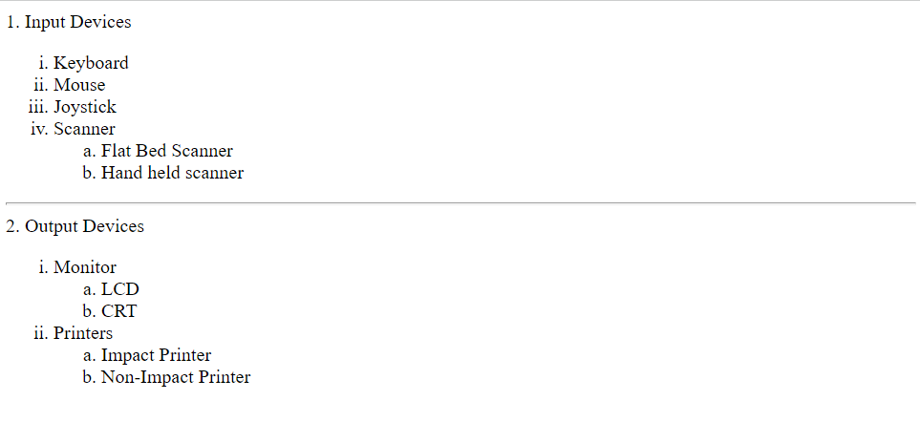

**PRACTICAL 8**

**Q**: To create table with rowspan and colspan

**CODE:**

<!DOCTYPE html>

<html lang="en">

<head>

    <title>col span use</title>

</head>

<body>

  <table border="4" align="center" cellpadding="30" style ="size:10px;">

    <tr>

        <th colspan="6">IP UNIVERSITY</th>

    </tr>

    <tr>

        <td colspan="3" align="center">GRADUATE</td>

        <TD COLSPAN="3" align="center">UNDERGRADUATE</TD>

    </tr>

    <TR>

        <tD>BBA</tD>

        <TD>BCA</TD>

        <TD>B tech</TD>

        <td>MBA</td>

        <TD>MCA</TD>

        <TD>M.tech</TD>

    </TR>

    <tr>

        <td>240</td>

        <td>120</td>

        <td>120</td>

        <td>200</td>

        <td>100</td>

        <td>80</td>

    </tr>

  </table>

</body>

</html>

**OUTPUT:**

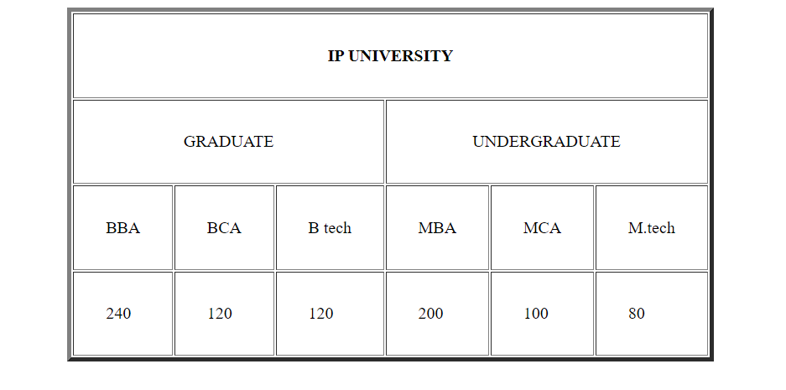

**PRACTICAL 9**

**Q**: Apply Marquee tag on image and text with all four directions and three behaviours.

**CODE:**

<!DOCTYPE html>

<html>

   <head>

      <title>HTML marquee Tag</title>

   </head>

   <body>

      <marquee direction = "left" behavior = "alternate">This text will scroll from right to left</marquee>

      <marquee direction = "right" behavior = "scroll">This text will scroll from left to right</marquee>

      <marquee direction = "up" behavior = "slide">This text will scroll from left to right</marquee>

      <marquee direction = "down" behavior = "alternate">This text will scroll from left to right</marquee>

      <marquee behavior="scroll" direction="left">

        <img src"https://www.w3schools.com/images/w3schools_green.jpg" width="120" height="80" alt="Natural" />

      </marquee>

   </body>

</html>

**OUTPUT:**

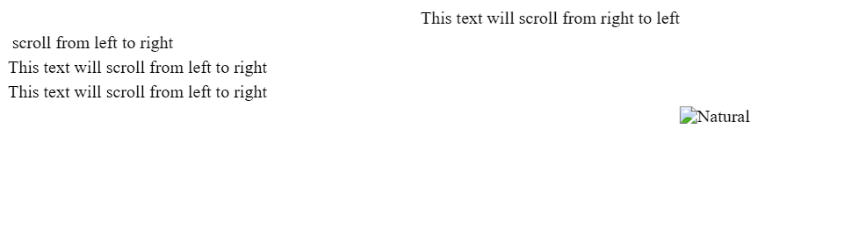

**PRACTICAL 10**

**Q**: Create a user registration form.

**CODE:**

<!DOCTYPE html>

<html>

    <head>

        <title>User Registration</title>

    </head>

    <body>

        <h1>User Registration</h1>

        <br>

        <form>

            <pre>

UserName:                                           <input type="text" name="username" id="username"><br>

Password:                                           <input type="text" name="password" id="password"><br>

Gender:                                             <input type="radio" name="male" value="male">Male<br>

                                                    <input type="radio" name="female" value="female">Female<br>

How did you hear about us?                          <select>

                                                        <option value="select">Select answer</option>

                                                        <option value="youTube">YouTube</option>

                                                        <option value="whatsapp">Whatsapp</option>

                                                        <option value="instagram">Instagram</option>

                                                    </select>

                                                    <br>

Please select this box if you wish

to be added to our mailing List                     <input type="checkbox" name="mail_list_check" id ="mail_list_check">

We will not pass  on your details to any third party.<br>

                                                    <input type="submit" value="Register Now">

            </pre>

    </form>

    </body>

</html>

**OUTPUT:**

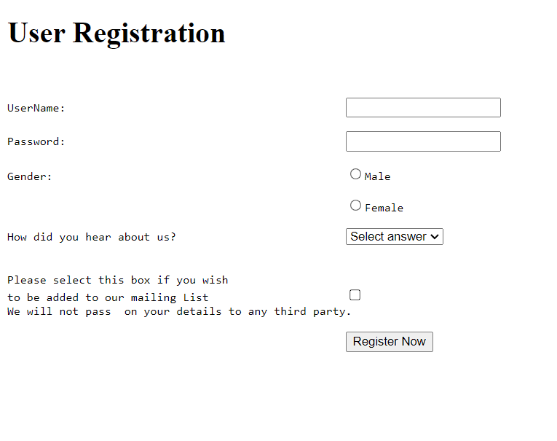

**PRACTICAL 11**

**Q**: Create a user form.

**CODE:**

<!DOCTYPE html>

<html>

    <head>

        <title>User Form</title>

    </head>

        <form>

            <table  border="5" cellpadding="3" bgcolor="#FFE6E3" cellspacing="5">

                <tr bgcolor="yellow">

                    <td align="center" colspan="2"><h1><font color="red">User Form</h1></td>

                </tr>

                <tr bgcolor="DeepSkyBlue">

                    <td>Enter Name</td>

                    <td><input type="text" id="name" name="name" style="background-color:#ccffcc;"></td>

                </tr>

                <tr bgcolor="DeepSkyBlue">

                    <td>Enter Password</td>

                    <td><input type="text" id="pass" name="pass" style="background-color:#ccffcc;"></td>

                </tr>

                <tr bgcolor="DeepSkyBlue">

                    <td>Enter Address</td>

                    <td><textarea name="address" rows="4" cols="40" style="background-color:#ccffcc;"></textarea></td>

                </tr>

                <tr bgcolor="DeepSkyBlue">

                    <td>Select Game</td>

                    <td>

                        <input type="checkbox" name="hockey" id="hockey" style="background-color:#ccffcc;">Hockey<br>

                        <input type="checkbox" name="football" id="football" style="background-color:#ccffcc;">Football<br>

                        <input type="checkbox" name="badminton" id="badminton" style="background-color:#ccffcc;">Badminton<br>

                        <input type="checkbox" name="cricket" id="cricket" style="background-color:#ccffcc;">Cricket<br>

                        <input type="checkbox" name="volleyball" id="volleyball" style="background-color:#ccffcc;">Volleyball<br>

                    </td>

                </tr>

                <tr bgcolor="DeepSkyBlue">

                    <td>Gender</td>

                    <td>

                        <input type="radio" name="male" value="male">Male

                        <input type="radio" name="female" value="female">Female

                    </td>

                </tr>

                <tr bgcolor="DeepSkyBlue">

                    <td>Select ur age</td>

                    <td>

                        <select style="background-color:#ccffcc;">

                            <option value="selans">Select</option>

                            <option value="lessthan18">Less than 18</option>

                            <option value="equalorabove18">Equal or above 18</option>

                        </select>

                    </td>

                </tr>

                <tr bgcolor="DeepSkyBlue">

                    <td colspan="2" align="center">

                        <input type="file" id="myFile" name="filename" style="background-color:#ccffcc;">

                    </td>

                </tr>

                <tr bgcolor="DeepSkyBlue">

                    <td colspan="2" align="center">

                        <input type="submit" id="clickme" value="Click Me" style="background-color:#ccffcc;">

                        <input type="submit" id="reset" value="Reset" style="background-color:#ccffcc;">

                        <input type="submit" id="submit_form" value="Submit Form" style="background-color:#ccffcc;">

                    </td>

                </tr>

            </table>

        </form>

    </body>

</html>

**OUTPUT:**

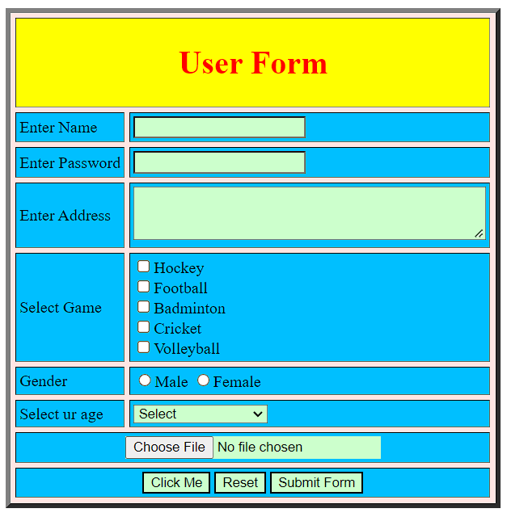

**PRACTICAL 12**

**Q**: Design of web page to display the syllabus of BCA clicking on each subject should open its description in new document (WTE,PYTHON,DBMS).

**CODE:**

#1 main.html

<!DOCTYPE html>

<html lang="en">

<head>

    <title>Hyperlink</title>

</head>

<body>

    <h3>Click to open Subject Description in new tab (_blank target)</h3>

    <ul>

        <li><a href="wte.html" target="_blank"> WTE</a></li>

        <li><a href="python.html" target="_blank">Python</a></li>

        <li><a href="dbms.html" target="_blank">DBMS</a></li>

    </ul>

</body>

</html>

#2 wte.html

<!DOCTYPE html>

<html>

    <head>

        <title>WTE</title>

    </head>

    <body>

        A website that allows people to buy and sell physical goods, services, and digital products over the internet rather than at a brick-and-mortar location. Through an e-commerce website, a business can process orders, accept payments, manage shipping and logistics, and provide customer service.

    </body>

</html>

#3 python.html

<!DOCTYPE html>

<html>

    <head>

        <title>WTE</title>

    </head>

    <body>

        Python is a computer programming language often used to build websites and software, automate tasks, and conduct data analysis. Python is a general-purpose language, meaning it can be used to create a variety of different programs and isn't specialized

    </body>

</html>

#4 dbms.html

<!DOCTYPE html>

<html>

    <head>

        <title>WTE</title>

    </head>

    <body>

        Database Management Systems (DBMS) are software systems used to store, retrieve, and run queries on data. A DBMS serves as an interface between an end-user and a database, allowing users to create, read, update, and delete data in the database.

    </body>

</html>

**OUTPUT:**

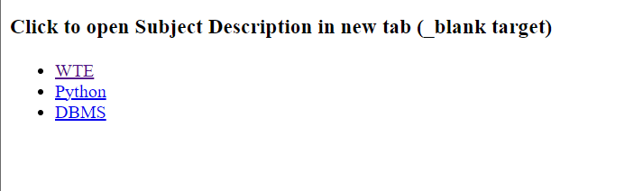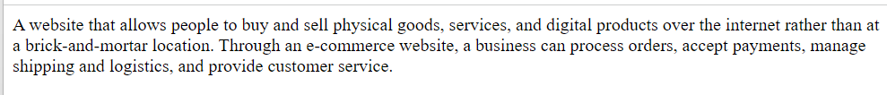

**PRACTICAL 13**

**Q**: Create a web page to show input and output devices with image. Clicking on the input and output devices image would open its description in a new document.

**CODE:**

**#1 main.html**

<!DOCTYPE html>

<html>

    <head>

        <title>I/O Devices</title>

    </head>

    <body>

        Click on photo (to view description)

        <ol>

            <li>

                Input Devices<br>

                <a href="keyboard.html" target="_blank">

                    <img src="keyboard.jpg" width="50px" height="50px" alt="Keyboard"/>

                </a><br>

                <a href="mouse.html" target="_blank">

                    <img src="mouse.jpg" width="50px" height="50px" alt="Mouse"/>

                </a>

            </li>

            <li>

                Output Devices<br>

                <a href="monitor.html" target="_blank">

                    <img src="monitor.jpg" width="50px" height="50px" alt="Monitor"/>

                </a>

            </li>

        </ol>

    </body>

</html>

#2 keyboard.html

<!DOCTYPE html>

<html>

    <head>

        <title>monitor</title>

    </head>

    <body>

        A keyboard is for putting information including letters, words and numbers into your computer. You press the individual buttons on the keyboard when you type.

    </body>

</html>

#3 mouse.html

<!DOCTYPE html>

<html>

    <head>

        <title>monitor</title>

    </head>

    <body>

        The mouse is a small, movable device that lets you control a range of things on a computer. Most types of mouse have two buttons, and some will have a wheel in between the buttons. Most types of mouse connect to the computer with a cable, and use the computer's power to work. Some types of mouse are wireless.

    </body>

</html>

#4 monitor.html

<!DOCTYPE html>

<html>

    <head>

        <title>monitor</title>

    </head>

    <body>

        A computer monitor is an output device that displays information in pictorial or textual form.    </body>

</html>

**OUTPUT:**

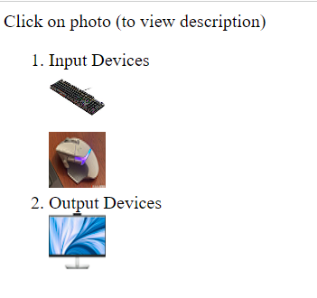

**PRACTICAL 14**

**Q**: Create a static web page which defines all text formatting tax in HTML in tabular form

**CODE:**

<!-- question 14 -->

<!DOCTYPE html>

<html lang="en">

<head>

    <title>Document</title>

</head>

<body>

    <table border="1px"  align="center">

        <tr>

        <th>Formatting tag</th>

        <th>Usage</th>

        </tr>

        <tr>

            <td>Bold</td>

            <td>used to bold the text</td>

        </tr>

        <tr>

            <td>Italic</td>

            <td>Used to italic the text</td>

        </tr>

        <tr>

            <td>Underline</td>

            <td>used to underline the text</td>

        </tr>

        <tr>

            <td>Emphasize</td>

            <td>Used to emphasize the text </td>

        </tr>

</body>

</html>

**OUTPUT:**

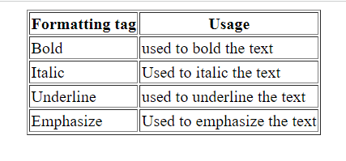

**PRACTICAL 15**

**Q**: Design a HTML webpage (Two frame division) of your favourite movie. Give an attractive look to it.

**CODE:**

#1 main.html

<html>

    <head>

        <title>main.html</title>

    </head>

    <frameset cols = "50%,50%" border="10">

        <frame name="Image" src="image.html">

        <frame name="Description">

    </frameset>

</html>

#2 image.html

<html>

    <head>

        <title>image.html</title>

    </head>

    <body>

        <h3>Click on photo to view Description</h3>

        <a href="doc.html" target="Description">

            <img src="lot.jpg" alt="image" width="75%" height="100%">

        </a>

    </body>

</html>

#3

<html>

    <head>

        <title>doc.html</title>

    </head>

    <body>

        <p>

            Thor: Love and Thunder is a 2022 American superhero

            film based on Marvel Comics featuring the character

            Thor, produced by Marvel Studios and distributed by

            Walt Disney Studios Motion Pictures. It is the sequel

            to Thor: Ragnarok (2017)

        </p>

    </body>

</html>

**OUTPUT:**

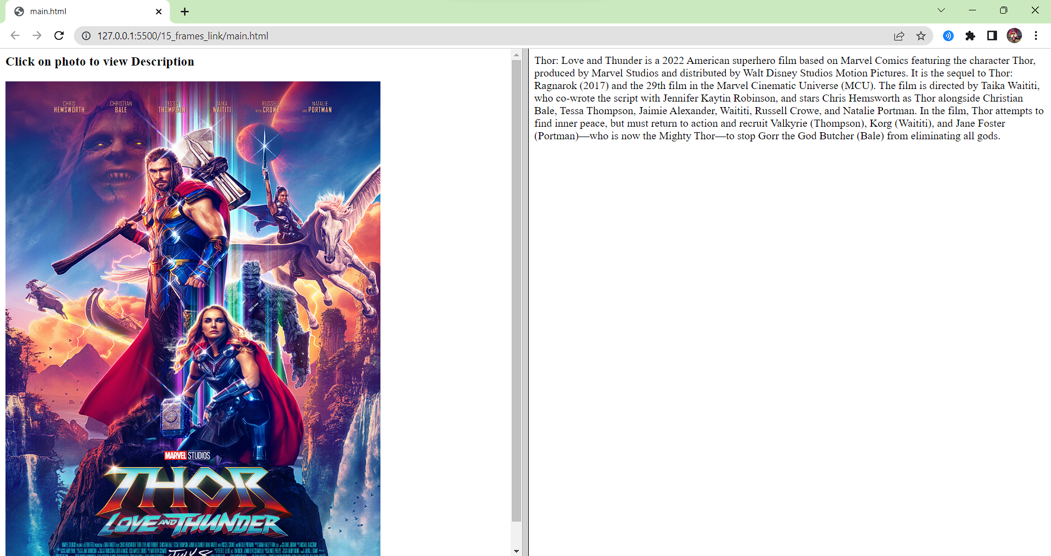

**PRACTICAL 16**

**Q**: Design a HTML webpage (Three frame division) of your favourite movie. Give an attractive look to it.

**CODE:**

#1 main.html

<html>

    <head>

        <title>main.html</title>

    </head>

    <frameset cols = "50%,50%" border="10">

        <frame name="main_menu" src="main_menu.html">

        <frameset rows="50%,50%" border="10">

            <frame name="explanation" src="explanation.html">

            <frame name="example" src="example.html">

        </frameset>

    </frameset>

</html>

#2 main_menu.html

<html>

    <head>

        <title>image.html</title>

    </head>

    <body>

        <center><h1>Main Menu</h1></center>

        <h2>

        <a href="lists.html" target="explanation">Lists</a><br>

        <a href="tables.html" target="explanation">Tables</a><br>

        <a href="frames.html" target="explanation">Frames</a><br>

        </h2>

    </body>

</html>

#3 example.html

<html>

    <body>

        <center><h1>Example</h1></center>

    </body>

</html>

#4 explanation.html

<html>

    <body>

        <center><h1>Explanation</h1></center>

    </body>

</html>

#5 list.html

<html>

    <head>

        <title>doc.html</title>

    </head>

    <body>

        <center><h1>Explanation</h1></center>

        <p>

            HTML Lists are used to specify lists of information. All lists may contain one or more list elements. There are three different types of HTML lists:

Ordered List or Numbered List (ol)

Unordered List or Bulleted List (ul)

Description List or Definition List (dl)

        </p>

        <a href="lists_img.html" target="example">View example</a>

    </body>

</html>

#6 list_img.html

<html>

    <head>

        <title>image.html</title>

    </head>

    <body>

        <center><h1>Example</h1></center>

        <img src="lists.png" alt="image" width="75%" height="100%">

    </body>

</html>

#7 tables.html

<html>

    <head>

        <title>doc.html</title>

    </head>

    <body>

        <center><h1>Explanation</h1></center>

        <p>

            HTML table tag is used to display data in tabular form (row * column). There can be many columns in a row.

            We can create a table to display data in tabular form, using "table" element, with the help of "tr" , "td", and "th" elements.

            In Each table, table row is defined by "tr" tag, table header is defined by "th", and table data is defined by "td" tags.

            HTML tables are used to manage the layout of the page e.g. header section, navigation bar, body content, footer section etc. But it is recommended to use div tag over table to manage the layout of the page .

        </p>

        <a href="tables_img.html" target="example">View example</a>

    </body>

</html>

#8 tables_img.html

<html>

    <head>

        <title>image.html</title>

    </head>

    <body>

        <center><h1>Example</h1></center>

        <img src="tables.png" alt="image" width="75%" height="100%">

    </body>

</html>

#9 frames.html

<html>

    <head>

        <title>doc.html</title>

    </head>

    <body>

        <center><h1>Explanation</h1></center>

        <p>

            HTML frame tag define the particular area within an HTML file where another HTML web page can be displayed.

            A frame tag is used with frameset, and it divides a webpage into multiple sections or frames, and each frame can contain different web pages.

        </p>

        <a href="frames_img.html" target="example">View example</a>

    </body>

</html>

#10 frames_img.html

<html>

    <head>

        <title>image.html</title>

    </head>

    <body>

        <center><h1>Example</h1></center>

        <img src="frames.png" alt="image" width="75%" height="100%">

    </body>

</html>

**OUTPUT:**

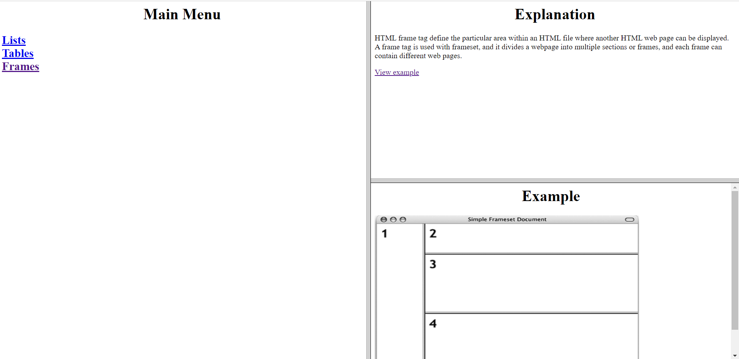

**PRACTICAL 17**

**Q**: Write a program to find out largest of two numbers in JavaScript.

**CODE:**

<!doctype html>

<html>

<head>

    <script>

        function largesstnum() {

            var num1, num2, num3;

            num1 = Number(document.getElementById("fnum").value);

            num2 = Number(document.getElementById("snum").value);

            if (num1 > num2) {

                window.alert(num1 + "-is Larger");

            }

            else if (num2 > num1) {

                window.alert(num2 + "-is Larger");

            }

            else if (num2 > num1 && num2 > num1) {

                window.alert(num2 + "is Larger");

            }

        }

    </script>

</head>

<body>

    <h1>Check largest number </h1>

    <br>

    Enter number 1: <input type="text" id="fnum"></input><br>

    Enter number 2: <input type="text" id="snum"></input><br>

    <button onclick="largesstnum()">submit</button>

</body>

</html>

**OUTPUT:**

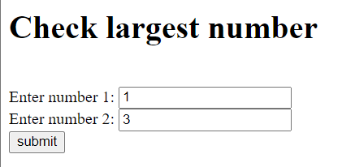 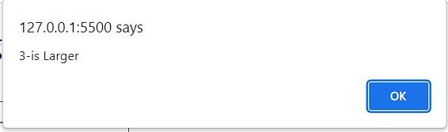

**PRACTICAL 18**

**Q**: Write a program to find the Fibonacci series in JavaScript.

**CODE:**

<html>

<head>

<title> Fibonacci Series in JavaScript </title>

</head>

<body>

<script>

// declaration of the variables

var n1 = 0,  n2 = 1, next_num, i;

var num = parseInt (prompt (" Enter the limit for Fibonacci Series "));

document.write( "Fibonacci Series: ");

for ( i = 1; i <= num; i++)

{  document.write (" <br> " +  n1); // print the n1

    next_num = n1 + n2; // sum of n1 and n2 into the next_num

    n1 = n2; // assign the n2 value into n2

    n2 = next_num; // assign the next_num into n2

}

</script>

</body>

</html>

**OUTPUT:**

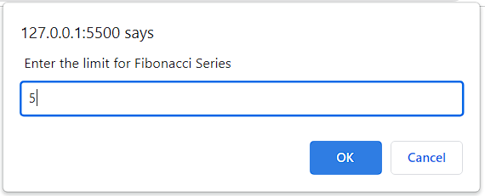 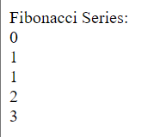

**PRACTICAL 19**

**Q**: Write a program in JavaScript to find out the year entered by the user is leap or not

**CODE:**

<html>

    <head>

        <title>Leap Year

        </title>

    </head>

    <body>

        <script type="text/javascript">

            function checkLeapYear(year){

            if((year%4==0)&&(year%100!=0)||(year%400==0)){

                document.write(year+' is a Leap Year');

            }

            else{

                document.write(year+' is not a Leap Year');

            }

        }

        // Take Input

        const year=prompt('Enter the year');

        checkLeapYear(year);

        </script>

    </body>

</html>

**OUTPUT:**

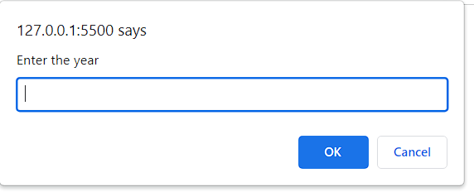 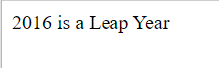

**PRACTICAL 20**

**Q**: Write a program to find out the largest of three numbers in PHP.

**CODE:**

<HTML>

    <HEAD>

        <SCRIPT>

            function Find(){

                var a=parseInt(document.getElementById("txta").value);

                var b=parseInt(document.getElementById("txtb").value);

                var c=parseInt(document.getElementById("txtc").value);

                var g=0;

                if(a>b){

                    if(a>c){

                        g=a;

                    }

                    else{

                        g=c;

                    }

                }

                else{

                    if(b>c){

                        g=b;

                    }

                    else{

                        g=c;

                    }

                }

                document.getElementById("txtd").value=""+g;

            }

        </SCRIPT>

    </HEAD>

    <BODY>

        <h2>Nested If : True/False ladder</h2>

        <hr />

        <table>

            <tr>

                <td>

                    <label>Enter A</label>

                </td>

                <td>

                    <input type="text" name="txta" id="txta" />

                </td>

            </tr>

            <tr>

                <td>

                    <label>Enter B</label>

                </td>

                <td>

                    <input type="text" name="txtb" id="txtb"  />

                </td>

            </tr>

            <tr>

                <td>

                    <label>Enter C</label>

                </td>

                <td>

                    <input type="text" name="txtc" id="txtc"  />

                </td>

            </tr>

            <tr>

                <td>

                    &nbsp;

                </td>

                <td>

                    <input type="button" value="Find" onclick="Find()" />

                </td>

            </tr>

            <tr>

                <td>

                    <label>Greater</label>

                </td>

                <td>

                    <input type="text" name="txtd" id="txtd" readonly />

                </td>

            </tr>

        </table>

    </BODY>

</HTML>

**OUTPUT:**

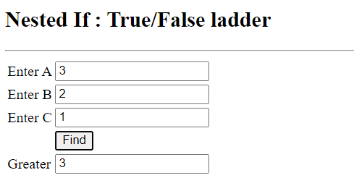

**PRACTICAL 21**

**Q**: Write a program in PHP to show that string entered is palindrome or not.

**CODE:**

<?php

function check_plaindrome($string) {

//remove all spaces

$string = str_replace(' ', '', $string);

//remove special characters

$string = preg_replace('/[^A-Za-z0-9\-]/', '', $string);

//change case to lower

$string = strtolower($string);

//reverse the string

$reverse = strrev($string);

if ($string == $reverse) {

echo "<p>It is Palindrome</p>";

}

else {

echo "</p>Not Palindrome</p>";

}

}

$string = "A man, a plan, a canal, Panama";

check_plaindrome($string);

?>

**OUTPUT:**

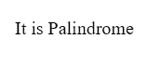

**PRACTICAL 22**

**Q**: Write a program in PHP to print the array of names of five subjects using for loop.

**CODE:**

<?php

// PHP program to print all

// the values of an array

// given array

$array = array("Python", "DBMS", "CN", "Graphics", "WEB");

// Loop through array

foreach($array as $item){

echo $item . "\n";

}

?>

**OUTPUT:**

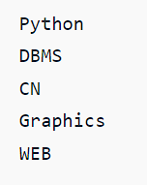

**PRACTICAL 23**

**Q**: Write a program in PHP to display a multidimensional array of class record of five students as Roll no., Student name and Total marks using for loop.

**CODE:**

<?php

// create multidimensional array

$classRec= array(

// Default key for each will start from 0

array(1,"sachin raj",93),

array(2,"ritik kr",95),

array(3,"harshita",91),

array(4,"tanu rya",89),

array(5,"himanshi",88)

);

$records = count($classRec);

// Display the array information

echo "Roll No. Student_name Total_marks \n";

for ($row = 0; $row < $records; $row+=1){

for ($col = 0; $col <3; $col += 1){

echo $classRec[$row][$col]."\t\t";

}

echo"\n";

}

?>

**OUTPUT:**

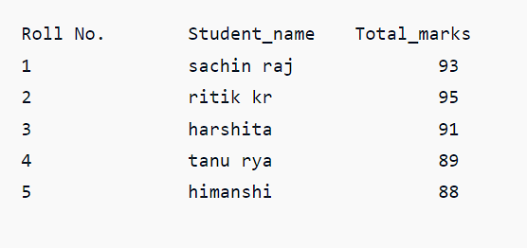

**PRACTICAL 24**

**Q**: Write a program in PHP to arrange the Price of five products in Ascending and descending order using all sort functions(sort, rsort, ksort, krsort, asort, arsort) in arrays

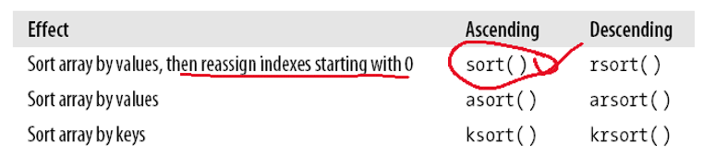

**CODE:**

<?php

$price = array("Keyboard"=>"999", "Mouse"=>"370", "Monitor"=>"5099","Ups"=>"2000","CPU"=>"24000");

sort($price);

foreach($price as $x => $x_value) {

echo "Key=" . $x . ", Value=" . $x_value;

echo "\n";

}

?>

**OUTPUT:**

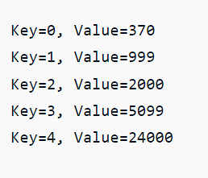 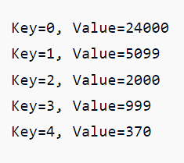

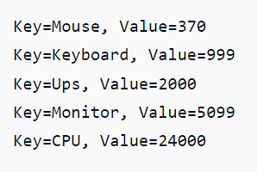 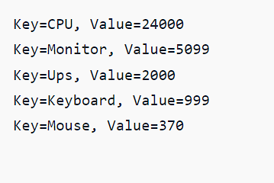

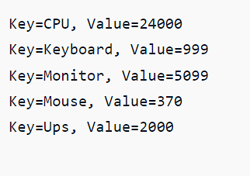 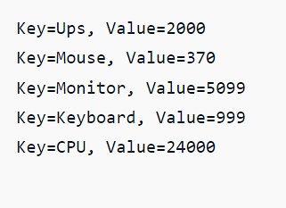

**PRACTICAL 25**

**Q**: Design the registration form for a web site and when the user clicks on submit button the login form should be appeared on the screen.

#Main.html

<!DOCTYPE html>

<html>

    <body>

        <form action="login.php" method="post">

            <div class="container">

              <h1>Register</h1>

              <p>Please fill in this form to create an account.</p>

              <hr>

              <label for="email"><b>Email</b></label>

              <input type="text" id="email" placeholder="Enter Email" name="email" id="email" required>

              <label for="psw"><b>Password</b></label>

              <input type="password" placeholder="Enter Password" name="psw" id="psw" required>

              <label for="psw-repeat"><b>Repeat Password</b></label>

              <input type="password" id =psw-repeat placeholder="Repeat Password" name="psw-repeat" id="psw-repeat" required>

              <hr>

              <p>By creating an account you agree to our <a href="#">Terms & Privacy</a>.</p>

              <button type="submit" class="registerbtn">Register</button>

            </div>

          </form>

    </body>

</html>

#Login.php

<?php

$pswrd = $_POST["psw"];

$email = $_POST["email"];

echo "Welcome $email, your password is $pswrd";

?>

**OUTPUTS:**

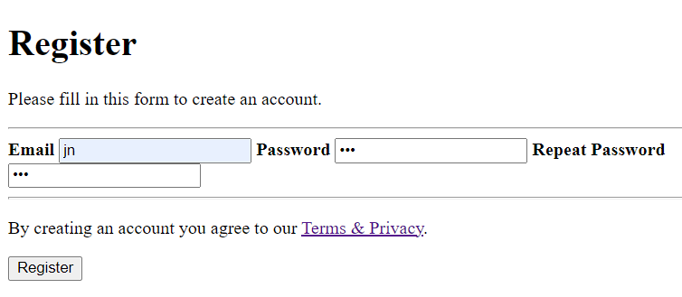

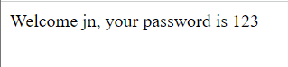

**PRACTICAL 26**

**Q**: Create a webpage displaying Questionnaire related to any survey of your choice.

**CODE:**

<!DOCTYPE html>

<html lang="en">

<head>

    <meta charset="UTF-8">

    <meta http-equiv="X-UA-Compatible" content="IE=edge">

    <meta name="viewport" content="width=device-width, initial-scale=1.0">

    <title>Build a Survey Form using HTML and CSS</title>

    <style>

        /* Styling the Body element i.e. Color, Font, Alignment */

        body {

            background-color: #add8e6;

            font-family: Verdana;

            text-align: center;

        }

        /* Styling the Form (Color, Padding, Shadow) */

        form {

            background-color: #fff;

            max-width: 500px;

            margin: 50px auto;

            padding: 30px 20px;

            box-shadow: 2px 5px 10px rgba(0, 0, 0, 0.5);

        }

        /* Styling form-control Class */

        .form-control {

            text-align: left;

            margin-bottom: 25px;

        }

        /* Styling form-control Label */

        .form-control label {

            display: block;

            margin-bottom: 10px;

        }

        /* Styling form-control input,

        select, textarea */

        .form-control input,

        .form-control select,

        .form-control textarea {

            border: 1px solid #777;

            border-radius: 2px;

            font-family: inherit;

            padding: 10px;

            display: block;

            width: 95%;

        }

        /* Styling form-control Radio

        button and Checkbox */

        .form-control input[type="radio"],

        .form-control input[type="checkbox"] {

            display: inline-block;

            width: auto;

        }

        /* Styling Button */

        button {

            background-color: #05c46b;

            border: 1px solid #777;

            border-radius: 2px;

            font-family: inherit;

            font-size: 21px;

            display: block;

            width: 100%;

            margin-top: 50px;

            margin-bottom: 20px;

        }

    </style>

</head>

<body>

    <h1>WebIdias Survey Form</h1>

    <!-- Create Form -->

    <form id="form">

        <!-- Details -->

        <div class="form-control">

            <label for="name" id="label-name">Name</label>

            <!-- Input Type Text -->

            <input type="text" id="name" placeholder="Enter your name" />

        </div>

        <div class="form-control">

            <label for="email" id="label-email">Email</label>

            <!-- Input Type Email-->

            <input type="email" id="email" placeholder="Enter your email" />

        </div>

        <div class="form-control">

            <label for="age" id="label-age">Age</label>

            <!-- Input Type Text -->

            <input type="text" id="age" placeholder="Enter your age" />

        </div>

        <div class="form-control">

            <label for="role" id="label-role">Which option best describes you?</label>

            <!-- Dropdown options -->

            <select name="role" id="role">

                <option value="student">Student</option>

                <option value="intern">Intern</option>

                <option value="professional">

                    Professional

                </option>

                <option value="other">Other</option>

            </select>

        </div>

        <div class="form-control">

            <label>Would you recommend WebIdias to a friend?</label>

            <!-- Input Type Radio Button -->

            <label for="recommed-1">

                <input type="radio" id="recommed-1" name="recommed">Yes</input>

            </label>

            <label for="recommed-2">

                <input type="radio" id="recommed-2" name="recommed">No</input>

            </label>

            <label for="recommed-3">

                <input type="radio" id="recommed-3" name="recommed">Maybe</input>

            </label>

        </div>

        <div class="form-control">

            <label>Languages and Frameworks known

                <small>(Check all that apply)</small>

            </label>

            <!-- Input Type Checkbox -->

            <label for="inp-1">

                <input type="checkbox" name="inp">C</input></label>

            <label for="inp-2">

                <input type="checkbox" name="inp">C++</input></label>

            <label for="inp-3">

                <input type="checkbox" name="inp">C#</input></label>

            <label for="inp-4">

                <input type="checkbox" name="inp">Java</input></label>

            <label for="inp-5">

                <input type="checkbox" name="inp">Python</input></label>

            <label for="inp-6">

                <input type="checkbox" name="inp">JavaScript</input></label>

            <label for="inp-7">

                <input type="checkbox" name="inp">React</input></label>

            <label for="inp-7">

                <input type="checkbox" name="inp">Angular</input></label>

            <label for="inp-7">

                <input type="checkbox" name="inp">Django</input></label>

            <label for="inp-7">

                <input type="checkbox" name="inp">Spring</input></label>

        </div>

        <div class="form-control">

            <label for="comment">Any comments or suggestions</label>

            <!-- multi-line text input control -->

            <textarea name="comment" id="comment"

                placeholder="Enter your comment here">

            </textarea>

        </div>

        <!-- Multi-line Text Input Control -->

        <button type="submit" value="submit">Submit</button>

    </form>

</body>

</html>

**OUTPUT:**

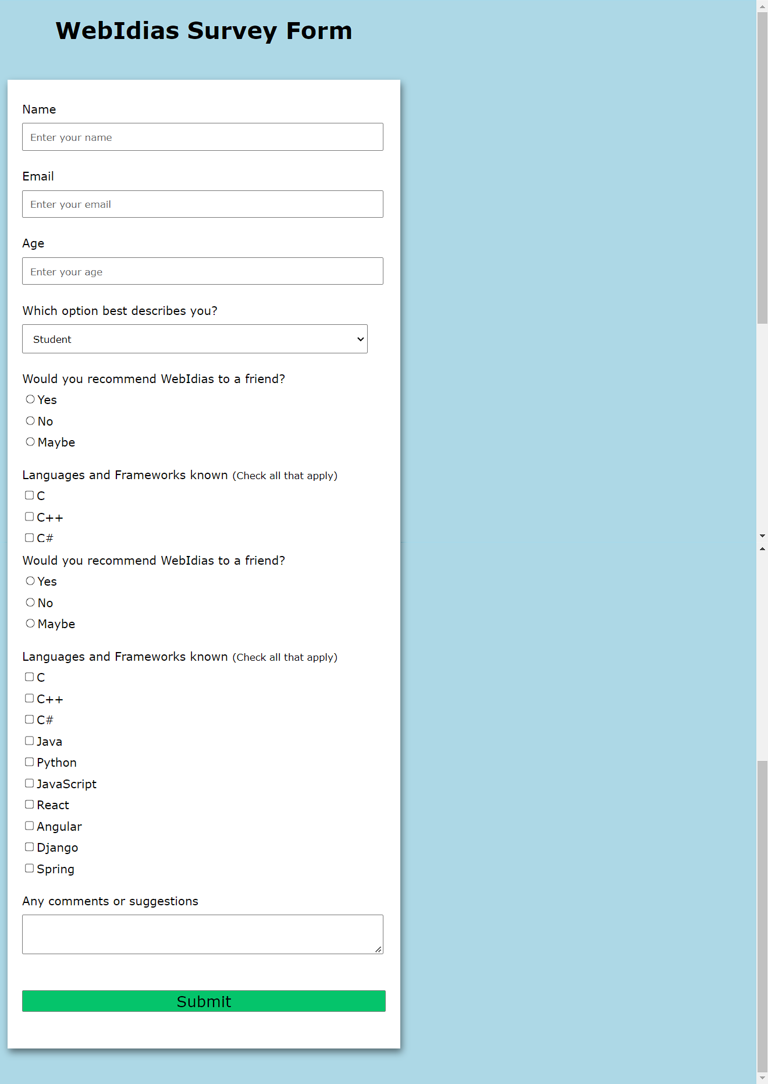

**PRACTICAL 27**

**Q**: Design a webpage presenting your Academic Details also format the details.

**CODE:**

<!DOCTYPE html>

<html>

<head>

    <title>Academic Information</title>

</head>

<body>

    <center><b><Font size=8>Academic Information</Font></b></center>

    <br>

    <b><font size=6> Full name:</b> Sachin Rajbhar</font>

    <br>

    <b><font size=6> Email  ID:</b> officialsachinrajbhar@gmail.com</font>

    <b><font size=6> &emsp; &emsp; &emsp; &emsp; &emsp; &emsp; &emsp; &emsp; &emsp; &emsp;  Contact No:</b> +91 8285895280</font><br>

    <b><font size=6> Father Name:</b> Firtoo Ram</font>

    <b><font size=6> &emsp; &emsp; &emsp; &emsp; &emsp; &emsp; &emsp; &emsp; &emsp; &emsp;&emsp;&emsp;&emsp;&emsp;&emsp;&emsp;&emsp;  Mother Name:</b> Sonmati Devi</font><br>

    <b><font size=6> Gender:</b> Male</font>

    <b><font size=6> &emsp; &emsp; &emsp; &emsp; &emsp; &emsp; &emsp; &emsp; &emsp; &emsp;&emsp;&emsp;&emsp;&emsp;&emsp;&emsp;&emsp;&emsp;&emsp;&emsp;&emsp;&emsp;  Date of Birth:</b> 30/03/2002</font><br>

    <br>

    <b><font size=6> Qualification Details</b></font>

    <br>

    <table border="1">

        <tr>

            <th><font size=6> &emsp;&emsp;&emsp;&emsp;Degree &emsp;&emsp;&emsp;&emsp; </font></th>

            <th><font size=6> &emsp;&emsp;&emsp;&emsp; Year of passing &emsp;&emsp;&emsp;&emsp; </font></th>

            <th><font size=6> &emsp;&emsp;&emsp;&emsp; College/School &emsp;&emsp;&emsp;&emsp; </font></th>

            <th><font size=6> &emsp;&emsp;&emsp;&emsp; Percentage &emsp;&emsp;&emsp;&emsp; </font></th>

        </tr>

        <tr>

            <td><font size="6"><center>BCA</center></font></td>

            <td><font size="6"><center>2024</center></font></td>

            <td><font size="6"><center>DSEU,Dwarka,Sec-9</center></font></td>

            <td><font size="6"><center>96%</center></font></td>

        </tr>

        <tr>

            <td><font size="6"><center>12th</center></font></td>

            <td><font size="6"><center>2020</center></font></td>

            <td><font size="6"><center>JBPS,Dwarka,Sec-3</center></font></td>

            <td><font size="6"><center>81.2%</center></font></td>

        </tr>

        <tr>

            <td><font size="6"><center>11th</center></font></td>

            <td><font size="6"><center>2018</center></font></td>

            <td><font size="6"><center>JBPS,Dwarka,Sec-3</center></font></td>

            <td><font size="6"><center>80.8%</center></font></td>

        </tr>

    </table>

    <br>

    <b><font size="6"> Declaration: </font></b>

    <br>

    I hereby declare that the above written particulars are true to the best of my knowledge and belief.

    <br>

    <br>

    <b><font size=6> Date:</b> 01/01/2023</font>

    <b><font size=6> &emsp; &emsp; &emsp; &emsp; &emsp; &emsp; &emsp; &emsp; &emsp; &emsp; &emsp;&emsp;&emsp;&emsp;&emsp;&emsp;&emsp;&emsp;&emsp;&emsp;&emsp; Place:</b> Delhi</font>

    <br>

    <b><font size=6> Photo:</b> <img src="https://www.w3schools.com/images/w3schools_green.jpg" alt="Photo" width="100" height="100"></font>

    <b><font size=6> &emsp; &emsp; &emsp; &emsp; &emsp; &emsp; &emsp; &emsp; &emsp; &emsp; &emsp;&emsp;&emsp;&emsp;&emsp;&emsp;&emsp;&emsp;&emsp;&emsp;&emsp; Sign:</b> <img src="https://www.w3schools.com/images/w3schools_green.jpg" alt="Sign" width="100" height="100"></font>

    <br>

</body>

</html>

**OUTPUT:**

